# **Caremark.com – Order Placement (Refill) Website**

|  |
| --- |
| **Scenario/Member Statements** |

Where can I order my prescriptions?

I forget when I last ordered my (Rx) can I see that online?

|  |
| --- |
| **Member to Place an Order** |

1.  Hover over the **Prescriptions** tab; click My Prescriptions from the menu or click My Prescriptions from the dashboard.

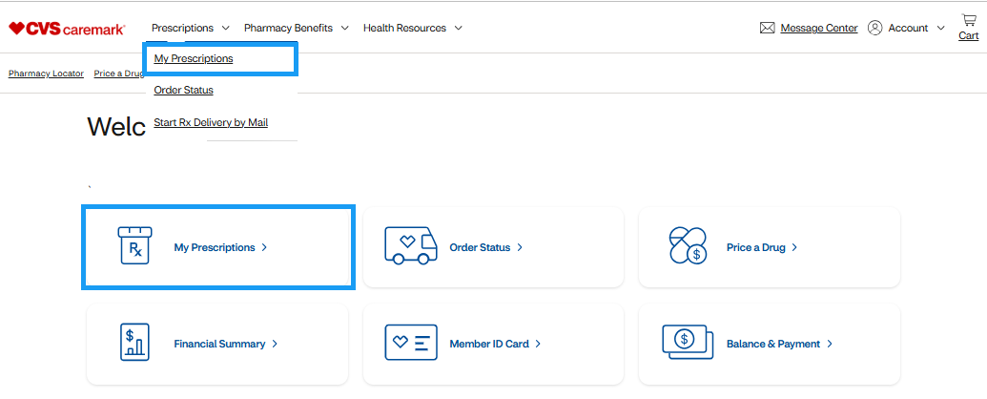

**Result: Your Prescriptions** page displays:

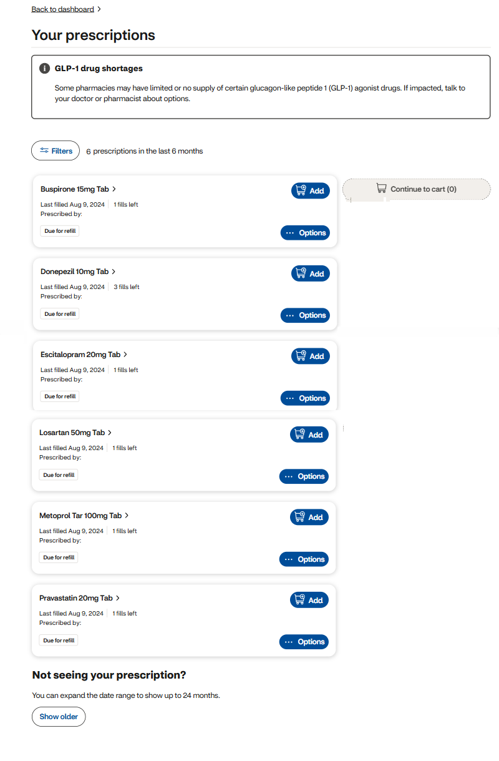

1. Click the **Add** box to continue to add the Medication to the **Continue to cart** box.

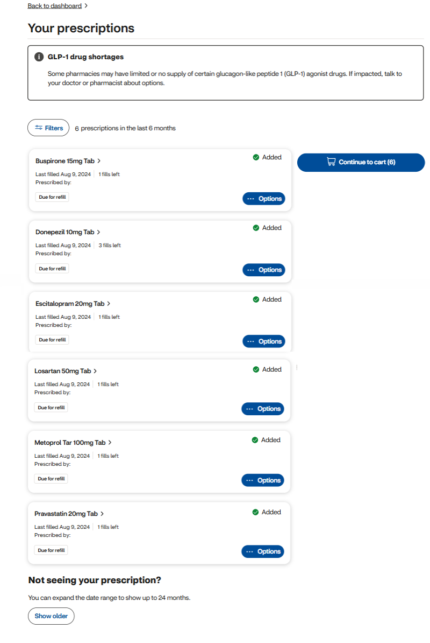

1. Once member has added all medications to their cart they will click **Continue to cart** button

**Result: Cart** page displays.

On this page the member can also:

* Change their delivery address.
* Change their delivery method (Next or Second Business Day).
* Add eligible medications to the automatic refill program.

1. Member clicks the **Checkout** button.

**Result: Check out** page displays.

On this page the member can also:

* Change their payment method.
* Review their order.

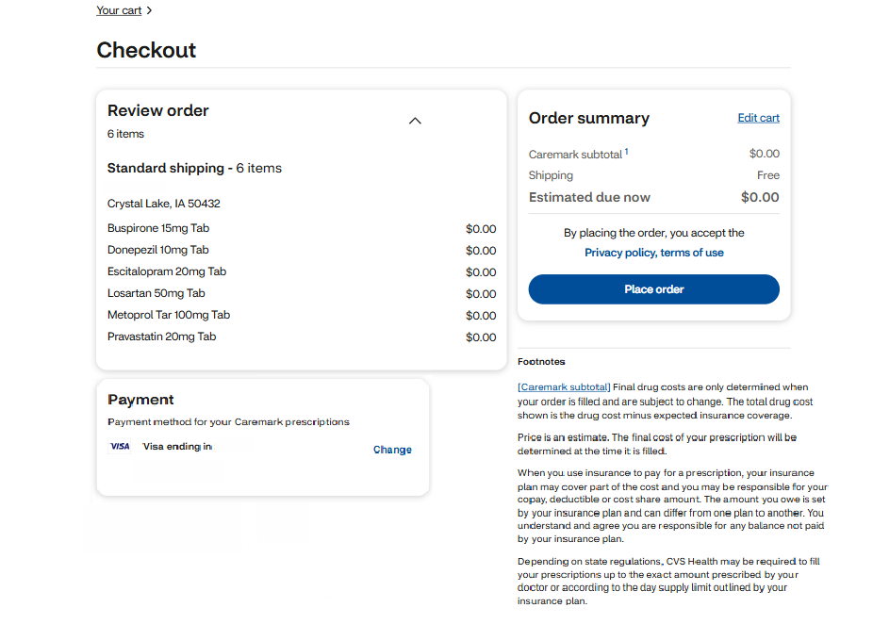

1. Member will click **Place order.**
   1. **Your order** page will populate with confirmation of the order placement.

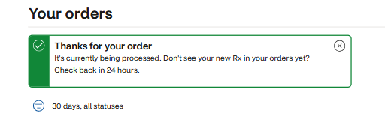

|  |
| --- |
| **Unable to Refill Prescriptions** |

Access the member’s account through Compass and determine if there is a registration associated with their current line of eligibility. If a member signs in and their account is inactive or not their current plan:

* Ask the member to click “View my plans.” Members see current, upcoming, and past plans in the last 36 months based on the termination date. If the member wants to access or view another plan, they simply select the plan and sign in again using the same username and password.
* Member mailed in new prescriptions or physician sent in new prescriptions electronically that are placed on Hold and not filled (**Example:** Too soon to fill). Members must contact Customer Care to request the first fill of the new prescription. After the new prescription is filled, the prescription will be available for the member to refill on Caremark.com going forward.
* If the member is still unable to refill their prescriptions or if they experience an error message while attempting to order/refill, submit a [Web Error Form](https://thesource.cvshealth.com/nuxeo/thesource/#!/view?docid=43ed6e8a-7e44-4cab-9831-eac9b6f67e7b).

|  |
| --- |
| **Member Transferred from Prior PBM** |

Except for circumstances indicated in the above section, members are able to view their transferred Prior PBM prescriptions when they register for their current/active plan.

|  |
| --- |
| **Related Documents** |

[Caremark.com - Common Member Assistance Call Types Index](https://thesource.cvshealth.com/nuxeo/thesource/#!/view?docid=947b0b38-401d-4b18-a08e-60348558a9b9)

**Full Details Document:**  [Caremark.com – View/Refill All Prescriptions - Integrated Pharmacy Experience (IPE)](https://thesource.cvshealth.com/nuxeo/thesource/#!/view?docid=ca9a6da8-e7b6-4eaf-aa3d-0c75eb4a6f06)

Not To Be Reproduced or Disclosed to Others Without Prior Written Approval

**ELECTRONIC DATA = OFFICIAL VERSION / PAPER COPY = INFORMATIONAL ONLY**